Meeting Agenda
1.) Roll Call
2.) Invocation and the Pledge of Allegiance
3.) Approve the Minutes and Finance Report of May 2022
4.) Approve all Accounts Payable for June 2022
5.) Amendments to the Agenda
6.) Public Participation for items on the Agenda

7.) Unfinished Business:
a) To discuss the DWRFL Project updates and inspections

8.) New Business:
a) Discuss and approve Mr. Jerry Cooley’s re-appointment for a 5-year term
b) Discuss and vote for President and Vice-President of the Board
c) LWCC 2022 Safety Grants Program in the amount of $2,500

9.) Maintenance Report: Jeremy Joffrion
a) System overview
b) Tools, Pipes and supplies
c) Any other reports

10.) Secretary Report: Paula Rose
a) Any reports

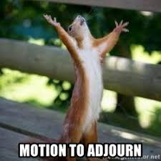
11) Adjourn

In accordance with the Americans with Disabilities Act, if you need special assistance, please contact Paula Rose at
337-462-6805 describing the assistance that is necessary.

